Name and Surname: Tshiamo Lebasi
Module: Web development introduction
Module code: WEDE5020
Assessment type: POE

Table of contents
Contents
Proposal 1 3
Organisation overview 3
Website Goals and Objectives 4
Current Website Analysis 4
Proposed website features and functionality 5
Design and user experience 5
Technical requirements 6
Timeline and milestones 6
Budget 6
References 7
Proposal 2 7
Organisation Overview 8
Website Goals and Objectives Goals: 8
KPIs: 8
Current Website Analysis 8
Proposed Website Features and Functionality 9
Design and User Experience 9
Timeline and Milestones 10
Budget 10
References 10
Content and research and sourcing 11
Site map 12

Part 1: building the foundation: project initiation and planning

MNYAMANE POWER SERVICES

Proposal 1

Organisation overview

Manyame Power Services was established in 2019 in Regents Park, Johannesburg. The company started by providing residential electrical repairs and has grown to offer commercial and industrial electrical solutions across Gauteng.

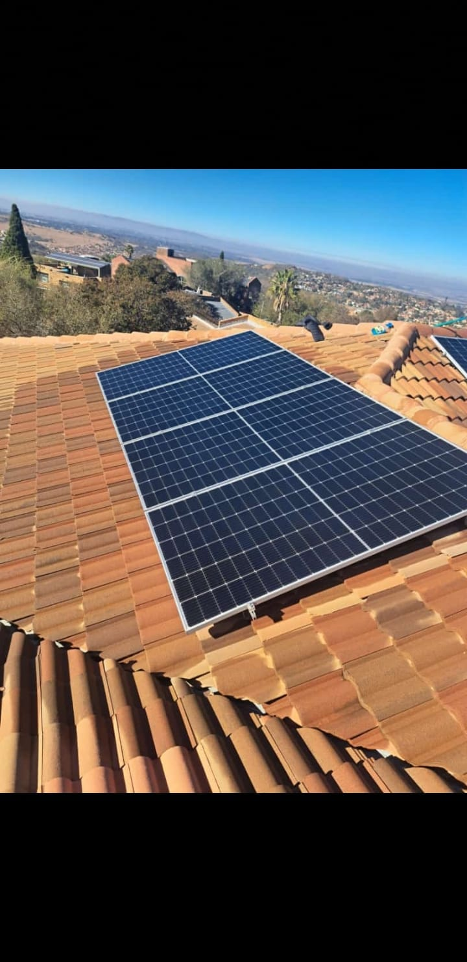
Mission: To deliver safe, reliable, and affordable power solutions to homes and businesses across Johannesburg.
Vision: To be the leading trusted electrical and renewable energy service provider in South Africa.
Target Audience: Homeowners, landlords, small businesses, and corporate clients in Johannesburg and surrounding areas. Secondary audience: Electricians seeking subcontract work.

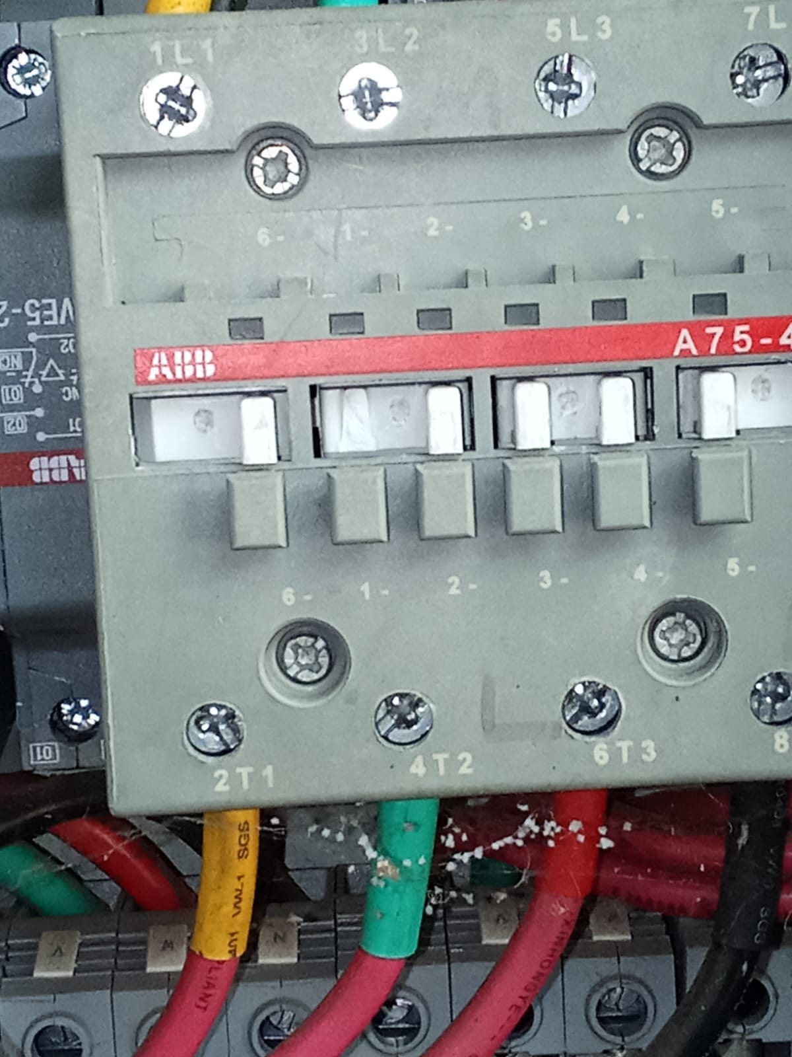

Website Goals and Objectives

Goals:
- Generate qualified service leads for electrical installations and repairs.
- Build trust and credibility as a registered and compliant electrical company.
- Promote new solar and backup power solutions due to load shedding.
KPIs:
- Number of "Get a Quote" form submissions per month
- Phone calls and WhatsApp click from the website
- Page views on "Solar Solutions" and "Services" pages
- Google search ranking for "electrician Johannesburg.

Current Website Analysis
Not applicable. Manyame Power Services currently relies on word-of-mouth and WhatsApp. Weakness: No online presence to showcase COC certificates, projects, or services. This causes lost leads to competitors with websites.
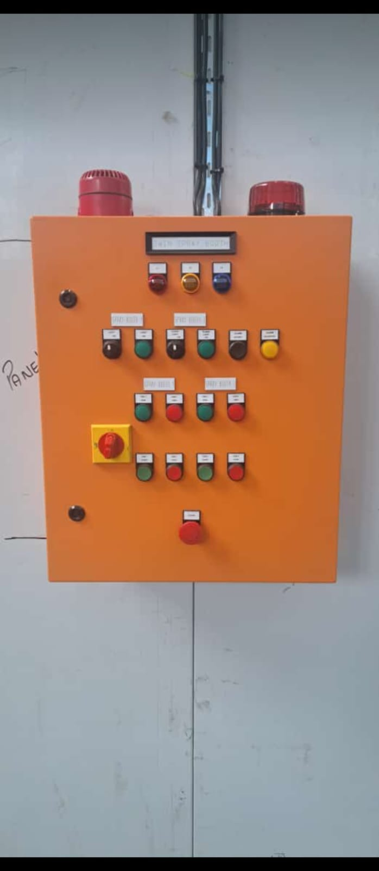

Proposed website features and functionality

Homepage: Hero banner with "24/7 Emergency Electrician", trust badges: "Registered, COC Certified"
About Us: Company history, licenses, team, safety record
Services Page: Residential, Commercial, Industrial, Solar, Backup Power, COC Issuing
Projects Gallery: Before/after photos of installations
Get a Quote Form: With service type, location, upload photos
Contact Page: Map to Regents Park office, WhatsApp button, emergency number
Blog: Load shedding tips, Eskom updates, electrical safety.

Design and user experience

Colour Scheme: Electric blue #0056b3, Safety yellow #FFC107, Dark Gray #333 for a professional, technical feel.
Typography: Roboto Bold for headings, Roboto Regular for body. Clear and readable for technical info.
Layout and Design: Clean, corporate layout. Prominent "Call Now" and "Get Quote" buttons. Mobile-first because clients will search on phone during emergencies.
UX Considerations: Fast loading, click-to-call, sticky header, simple 3-step quote form.
Wireframes: Wireframe 1: Homepage with services grid.
Wireframe 2: Service detail page.
Wireframe 3: Quote form.

Technical requirements
Domain: manyamepower.co.za
Hosting: Business cPanel hosting in South Africa for fast load times + SSL
Languages/Frameworks: HTML5, CSS3, JavaScript. CMS: WordPress + Elementor for easy updates.
Other: WhatsApp Business API button, Contact Form 7, Google Maps, SEO plugin.

Timeline and milestones
Week 1: Research competitors, gather content and project photos
Week 2-3: Wireframes, UI design, and client approval
Week 4-5: Development and form integration
Week 6: SEO setup, testing, and launch

Budget
Domain Registration: R150 per year SA
Hosting + SSL: R1,800 per year
Website Development: R9,500 once-off
Maintenance + SEO: R700 per month Estimated Year 1 Total: R19,850

References
Department of Labour. (2025). Electrical COC Requirements SA.
WordPress. (2025). Elementor Page Builder.
Google Maps API. (2025). Location services.

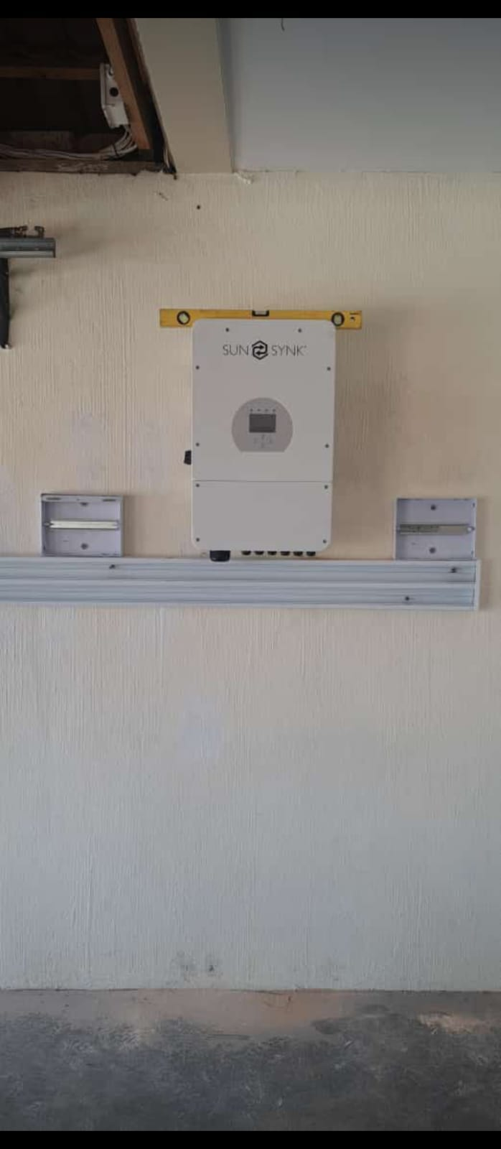

Proposal 2

Organisation Overview
Name: Dlok's Braai Spot
Brief History: Dlok's Braai Spot was started in 2021 in Johannesburg. It began as a weekend backyard braai and grew into a popular takeaway spot known for authentic South African township cuisine. The business specializes in grilled meats, gizzards, chicken feet "walkways", and cow feet "mogodu".
Mission: To serve affordable, flavourful, and authentic braai and traditional meals that bring the community together.
Vision: To be Johannesburg’s go-to spot for real township braai and comfort food.
Target Audience: Local community members, students, taxi drivers, and workers aged 18-45 in Johannesburg. Secondary audience: Customers ordering for events and weekend gatherings.

Website Goals and Objectives Goals:
Increase takeaway and bulk orders through online ordering.
Showcase the menu with photos to attract new customers.
Build brand identity for Dlok's Braai Spot and promote daily specials.

KPIs:
Number of online orders and WhatsApp inquiries per week
Menu page views and time spent on gallery
Social media clicks from the website
Customer feedback form submissions

Current Website Analysis
Not applicable. Dlok's Braai Spot currently operates with no website and relies on word-of-mouth, WhatsApp status, and foot traffic. Weakness: Customers can't see the menu, prices, or operating hours before coming. No way to place orders ahead of time, leading to long queues.

Proposed Website Features and Functionality
Homepage: Hero image of braai, "Order Now" button, daily specials banner
Menu Page: Categories: Braai Meat, Gizzards, Chicken Feet, Cow Feet, Pap & Sides. Each item has photo and price
Gallery: Photos of cooked food - gizzards, chicken feet, cow feet, ribs
Order Online: WhatsApp order button + simple order form with pickup time
About Us: Story of Dloks, location, and community focus
Contact Page: Google Maps to location, phone number, operating hours, WhatsApp link
Events: Catering for birthdays, funerals, and parties

Design and User Experience
Colour Scheme: Charcoal black #222, Flame orange #FF4500, White #FFF for a bold, smoky braai feel.
Typography: Oswald Bold for headings, Montserrat for body. Big and readable for menu prices.
Layout and Design: Food-first design with large photos of grilled meat. Mobile-first because most customers will view on phone.
UX Considerations: 1-click WhatsApp order, sticky "Call to Order" button, fast loading images, simple menu navigation.
Wireframes: Wireframe 1: Homepage with specials and CTA. Wireframe 2: Menu with food photos. Wireframe 3: Order/Contact page with map.
Technical Requirements
Domain: dloksbraaispot.co.za
Hosting: Affordable SA-based shared hosting + SSL certificate
Languages/Frameworks: HTML5, CSS3, JavaScript. CMS: WordPress for easy menu updates.
Other: WhatsApp Business integration, Google Maps embed, image gallery plugin, mobile responsive design.

Timeline and Milestones
Week 1: Take photos of food, gather menu and pricing
Week 2: Wireframes and design approval
Week 3-4: Website development and WhatsApp integration
Week 5: Testing, SEO for "braai near me", and launch8.

Budget
Domain Registration: R150 per year
SA Hosting + SSL: R1,200 per year
Website Development + Food Photography: R6,500 once-off
Maintenance and Updates: R400 per month Estimated Year 1 Total: R12,650*9.

References
WordPress. (2025). Restaurant website templates.
WhatsApp Business. (2025). Click-to-chat API.
Google. (2025). Google Maps for Business.

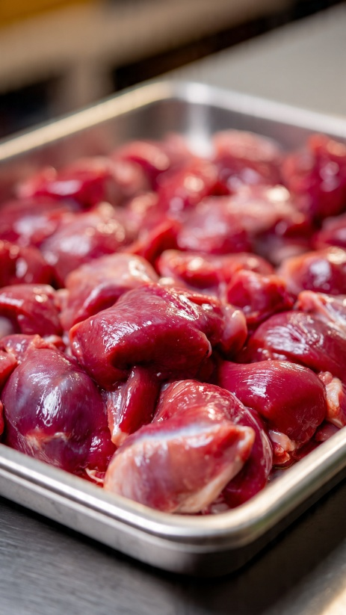

Content and research and sourcing
Mnyamane power services
To develop content for the Mnyamane Power Services website, information was gathered from four main sources.
First, we checked for an existing organization website, but as Mnyamane Power Services is a new company, no website was available yet.
Second, we conducted research on social media platforms such as Facebook and Instagram. We reviewed pages of other electrical and solar companies in Johannesburg South to understand customer needs during load shedding and to see how competitors present their services.
Third, we sourced visuals from public domain and Creative Commons resources. Free images of electricians and solar installations were provided by the co-founder of Mynamane Power Services. Lastly, we created original content. All text including the "About Us" section, service descriptions, mission statement, and the 2026 price list was written specifically for Mnyamane Power Services to address the needs of homeowners and businesses affected by power outages.

Site map

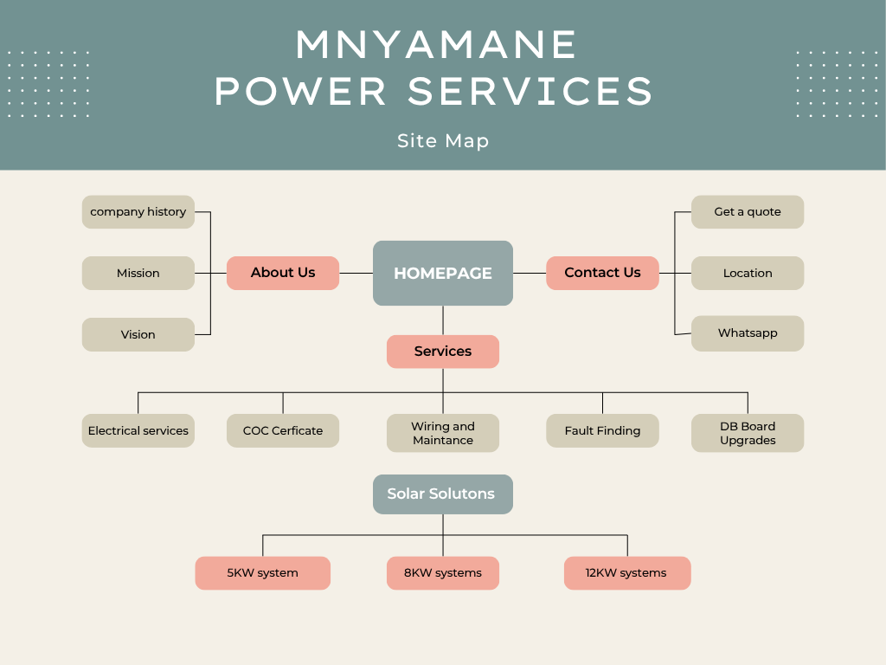

Github link
Mnyamane Power Services GitHub link

Final Professional link
http://mnyamane-power-tshiamo.netlify.app/

